Capstone Project | My Movie

Testing Web-API

1. User
   1. Save

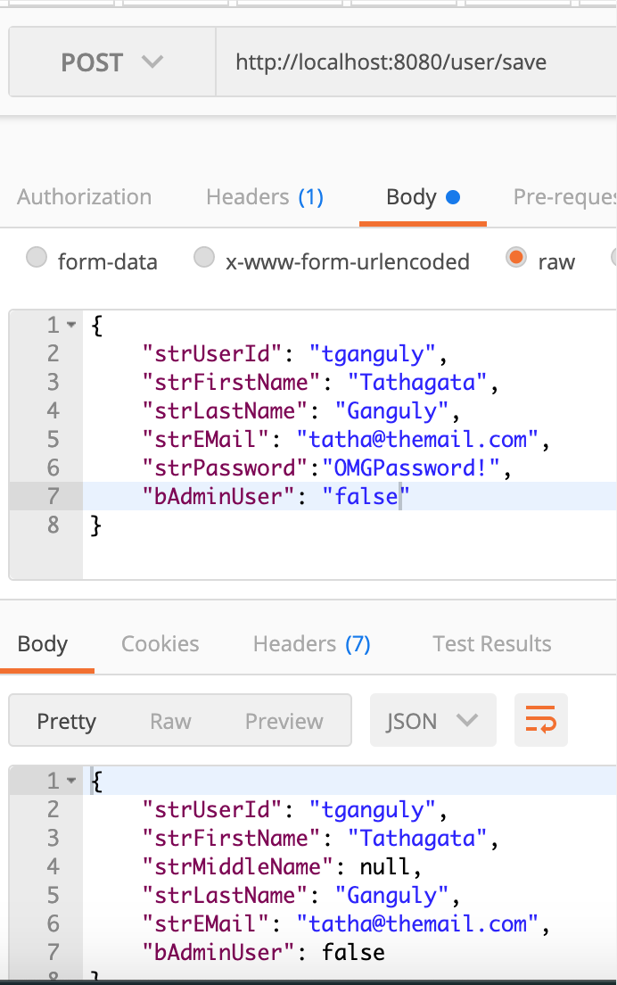 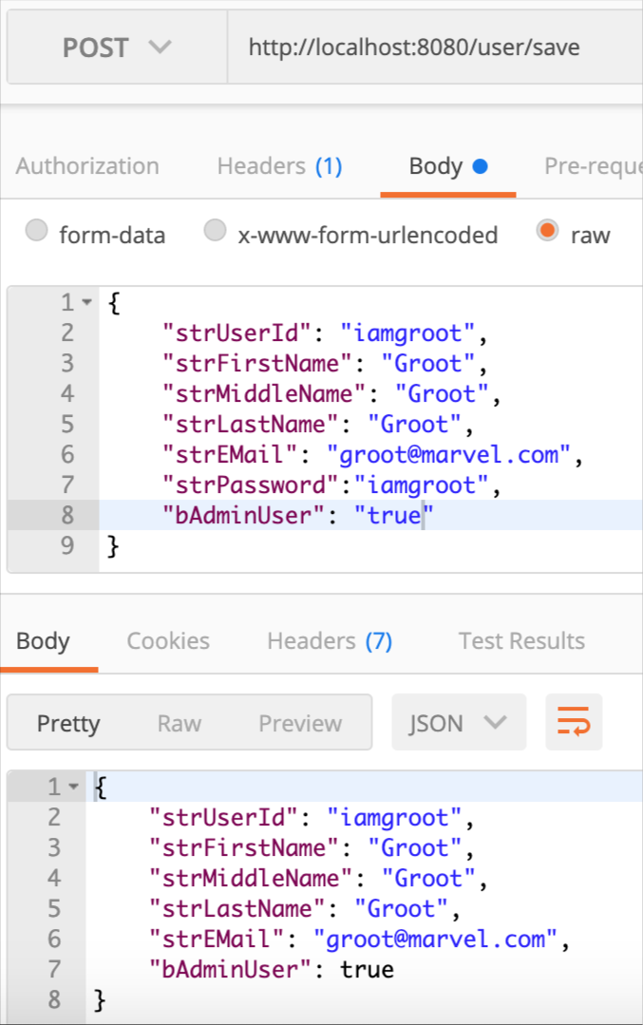

* 1. Find by ID

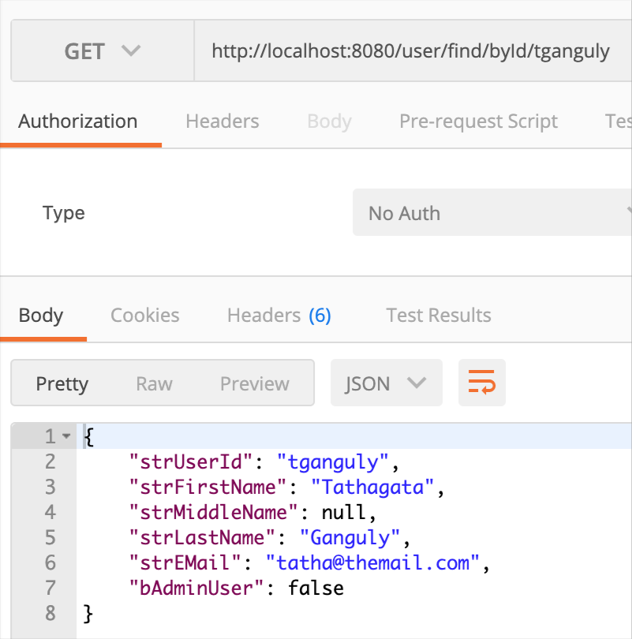

* 1. Authentication

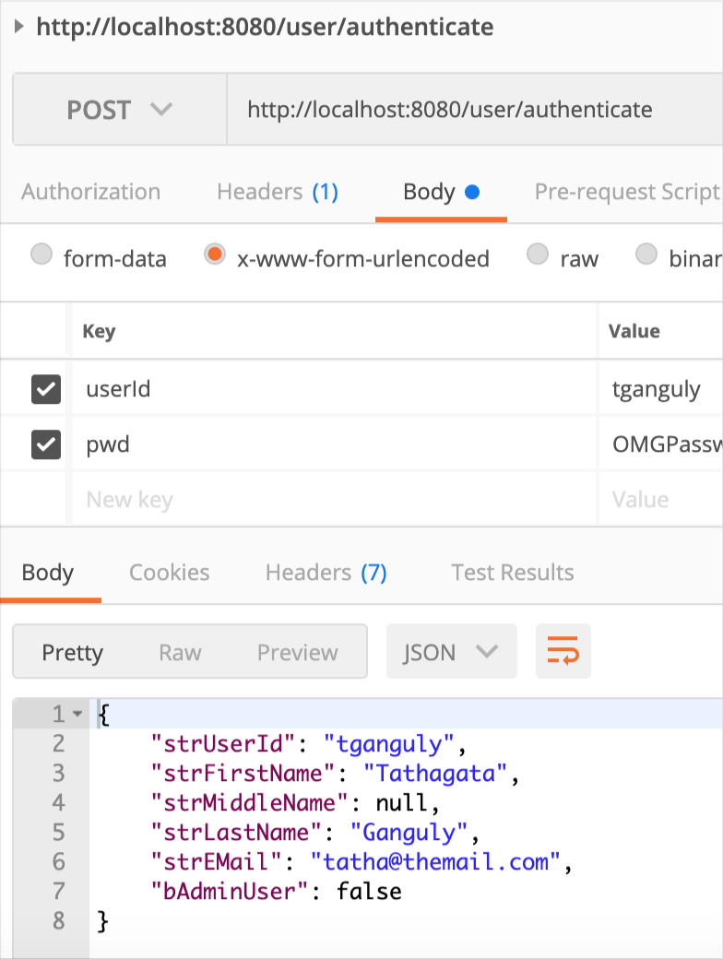

1. Movie
   1. Save

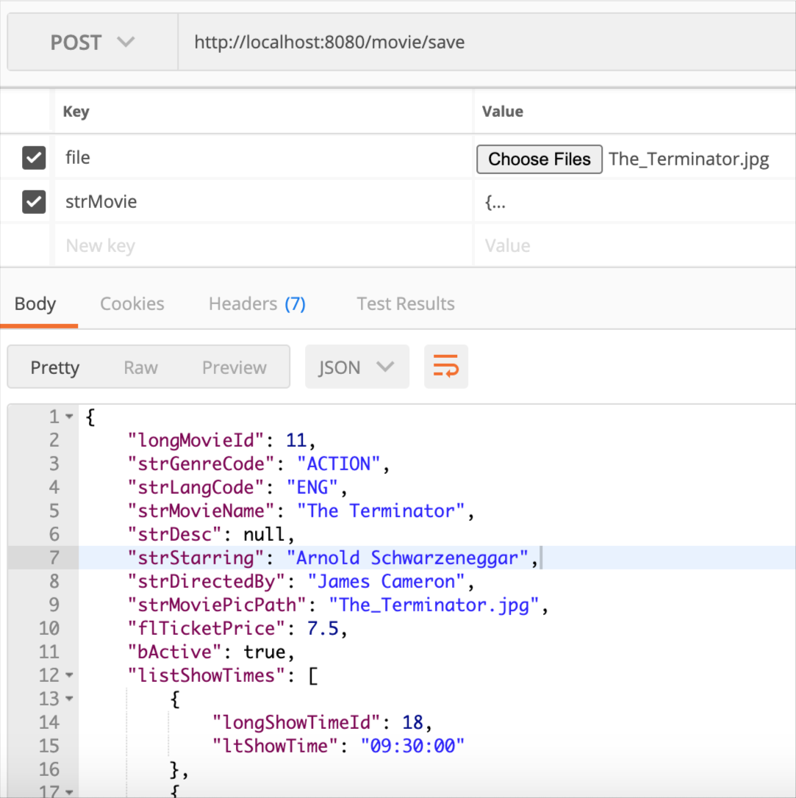

* 1. Find by Keyword

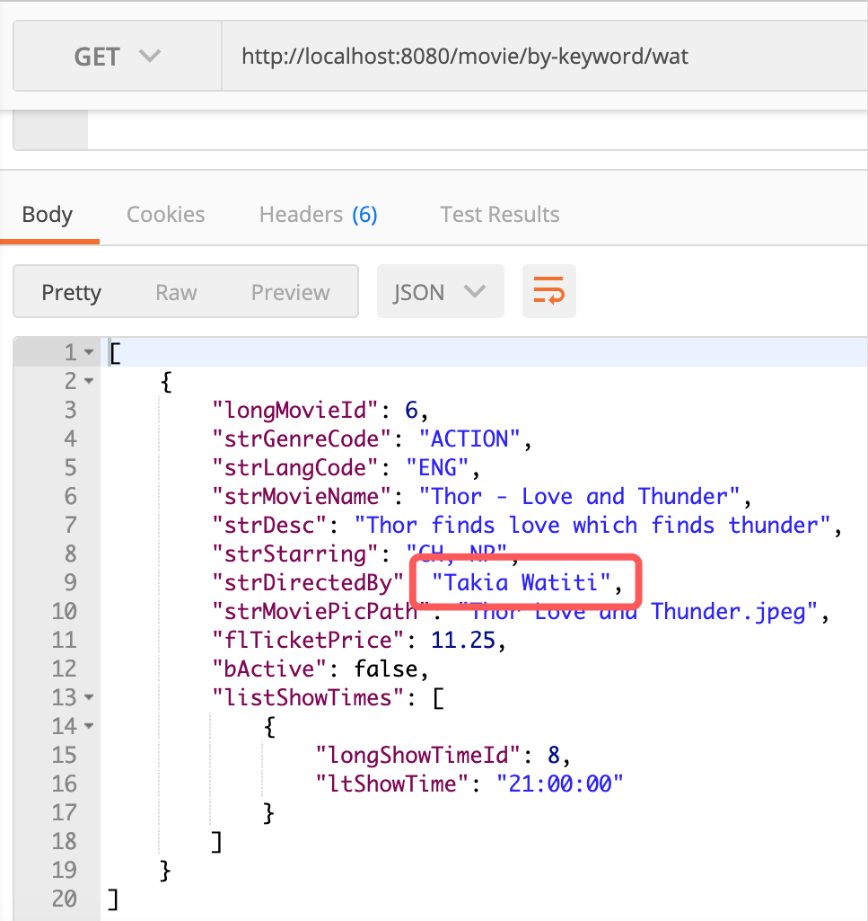

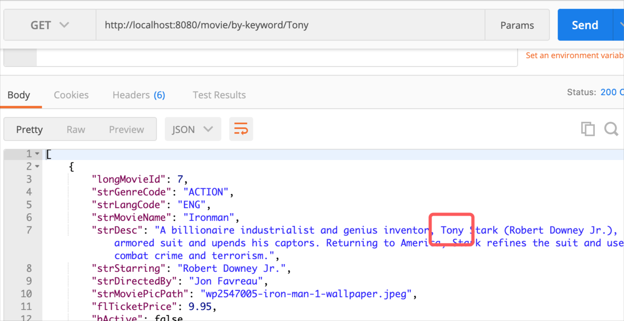

* 1. Genres

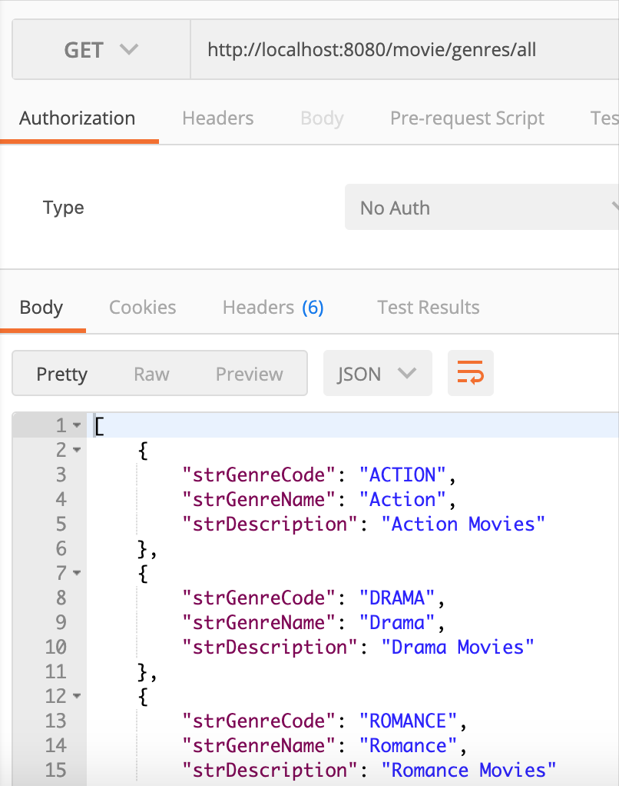

* 1. Languages

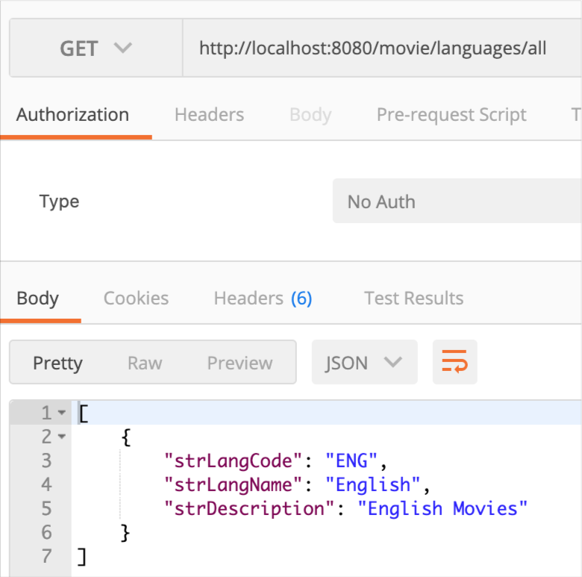

1. Purchase
   1. Save

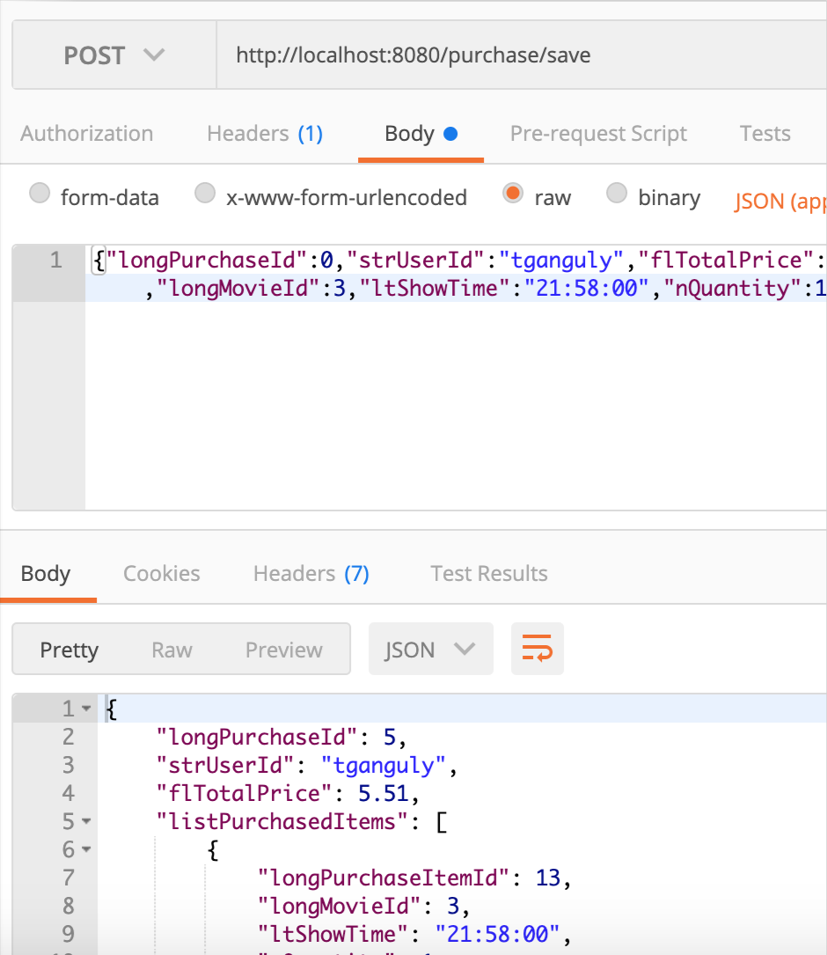

App Testing and Demo.

1. Dashboard
   1. Carousel and other controls in the Header

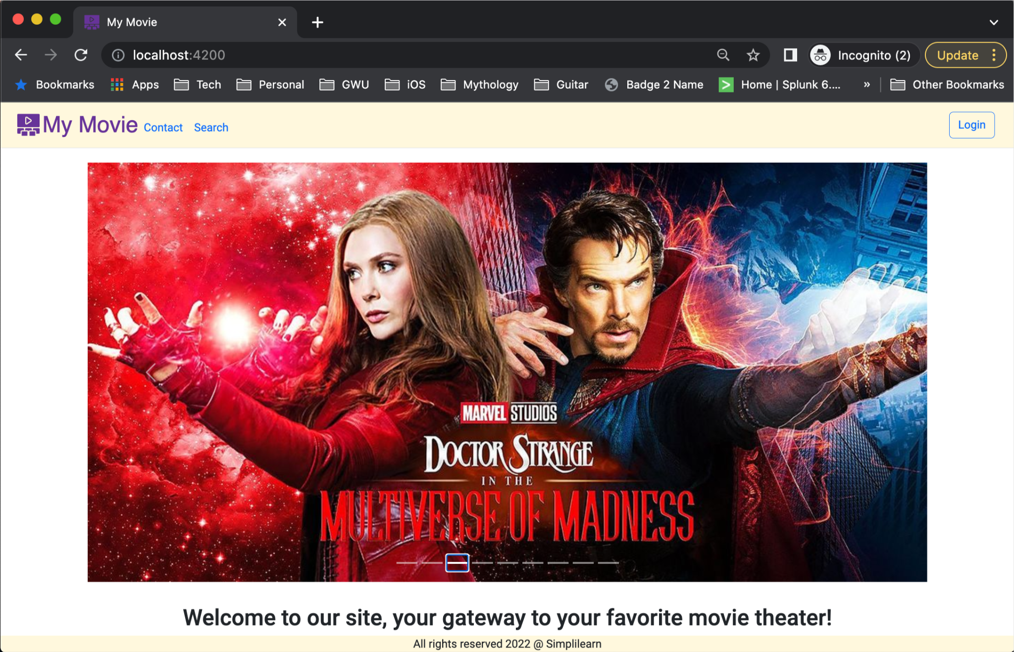

1. Contact
   1. Displays a Modal Dialogue with Contact Information

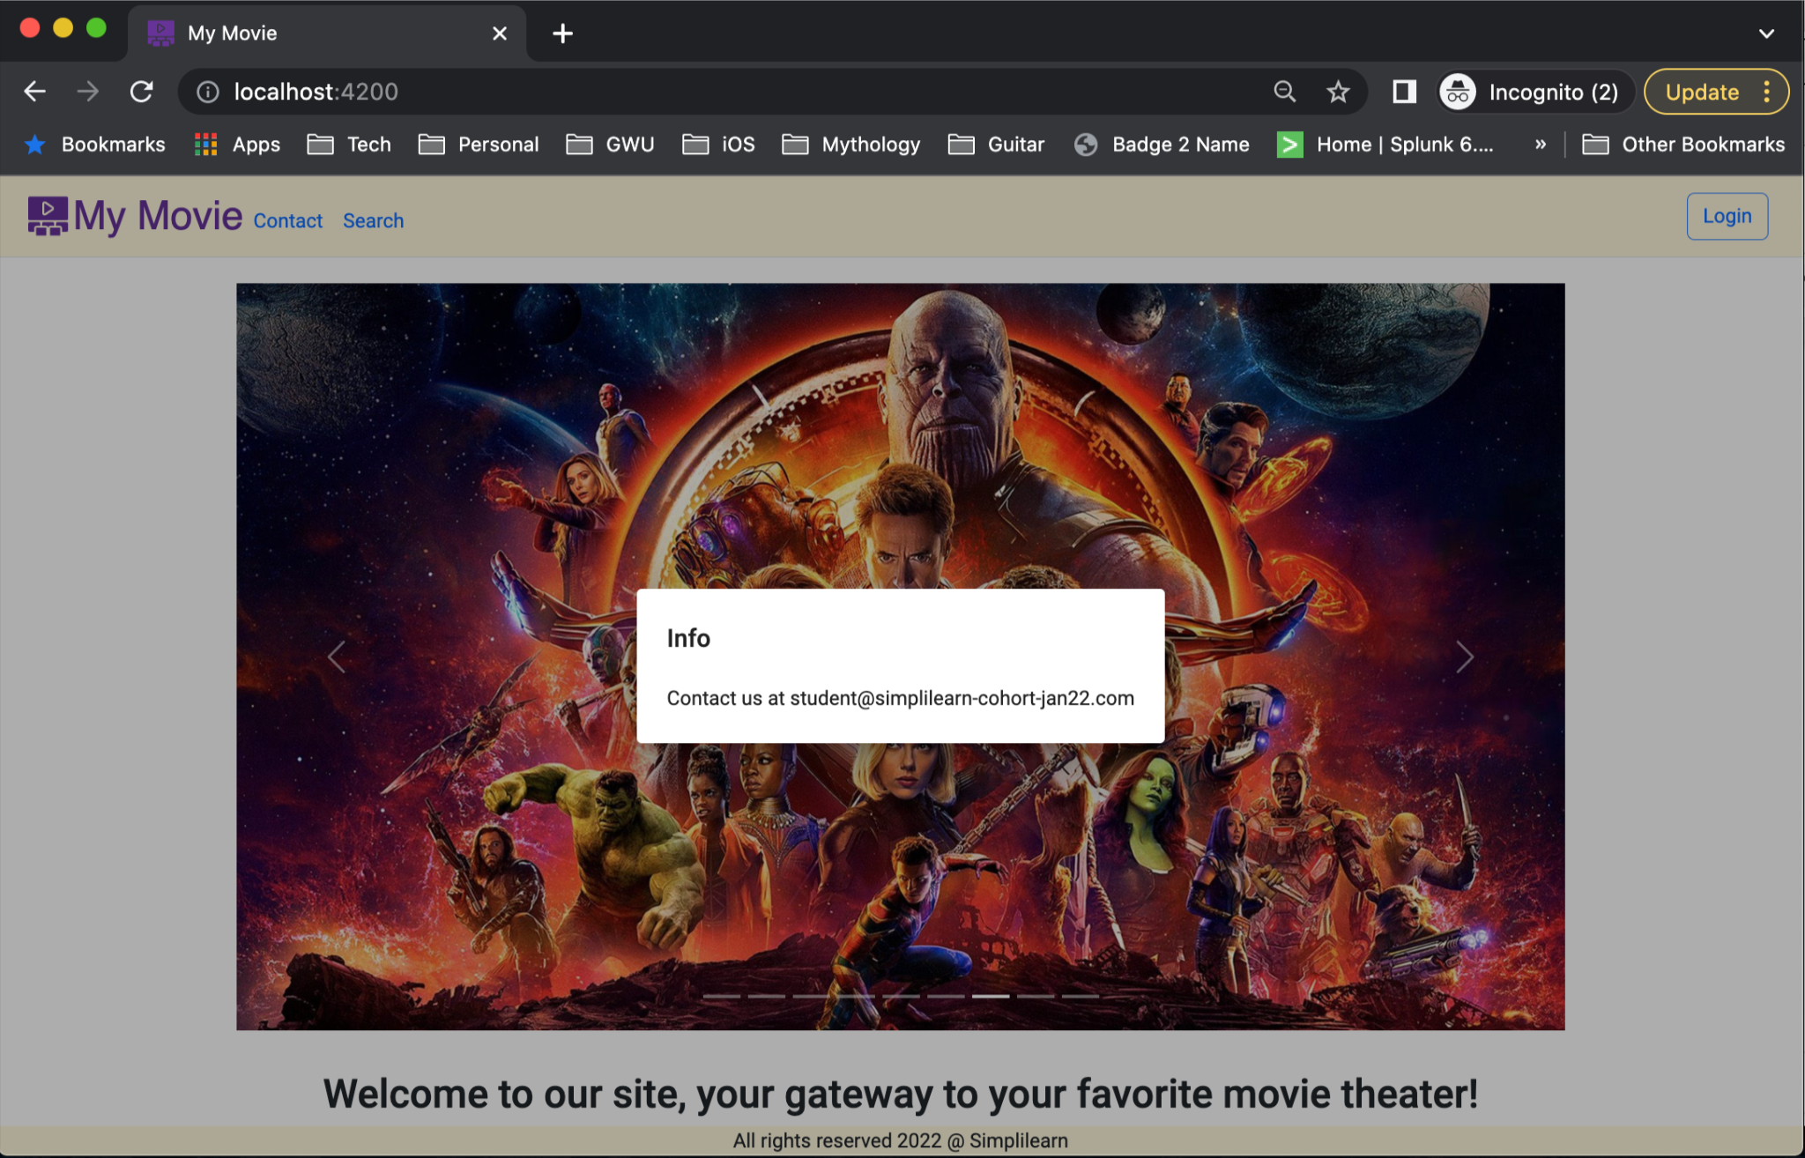

1. Search
   1. Landing page shows all movies

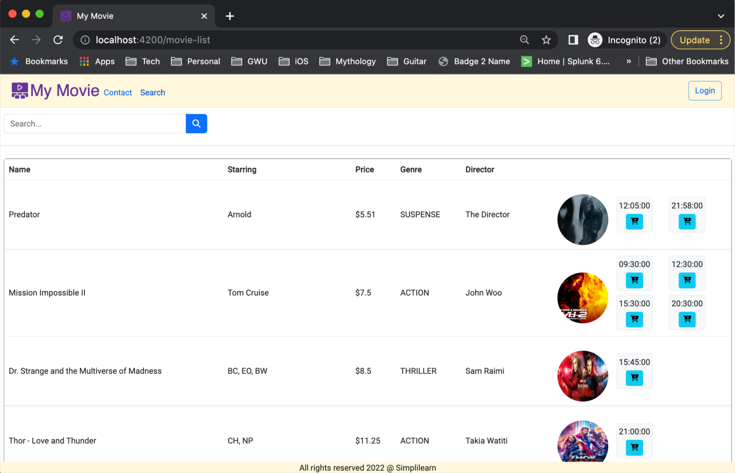

* 1. Click on a movie’s show-time and it gets immediately added to the cart

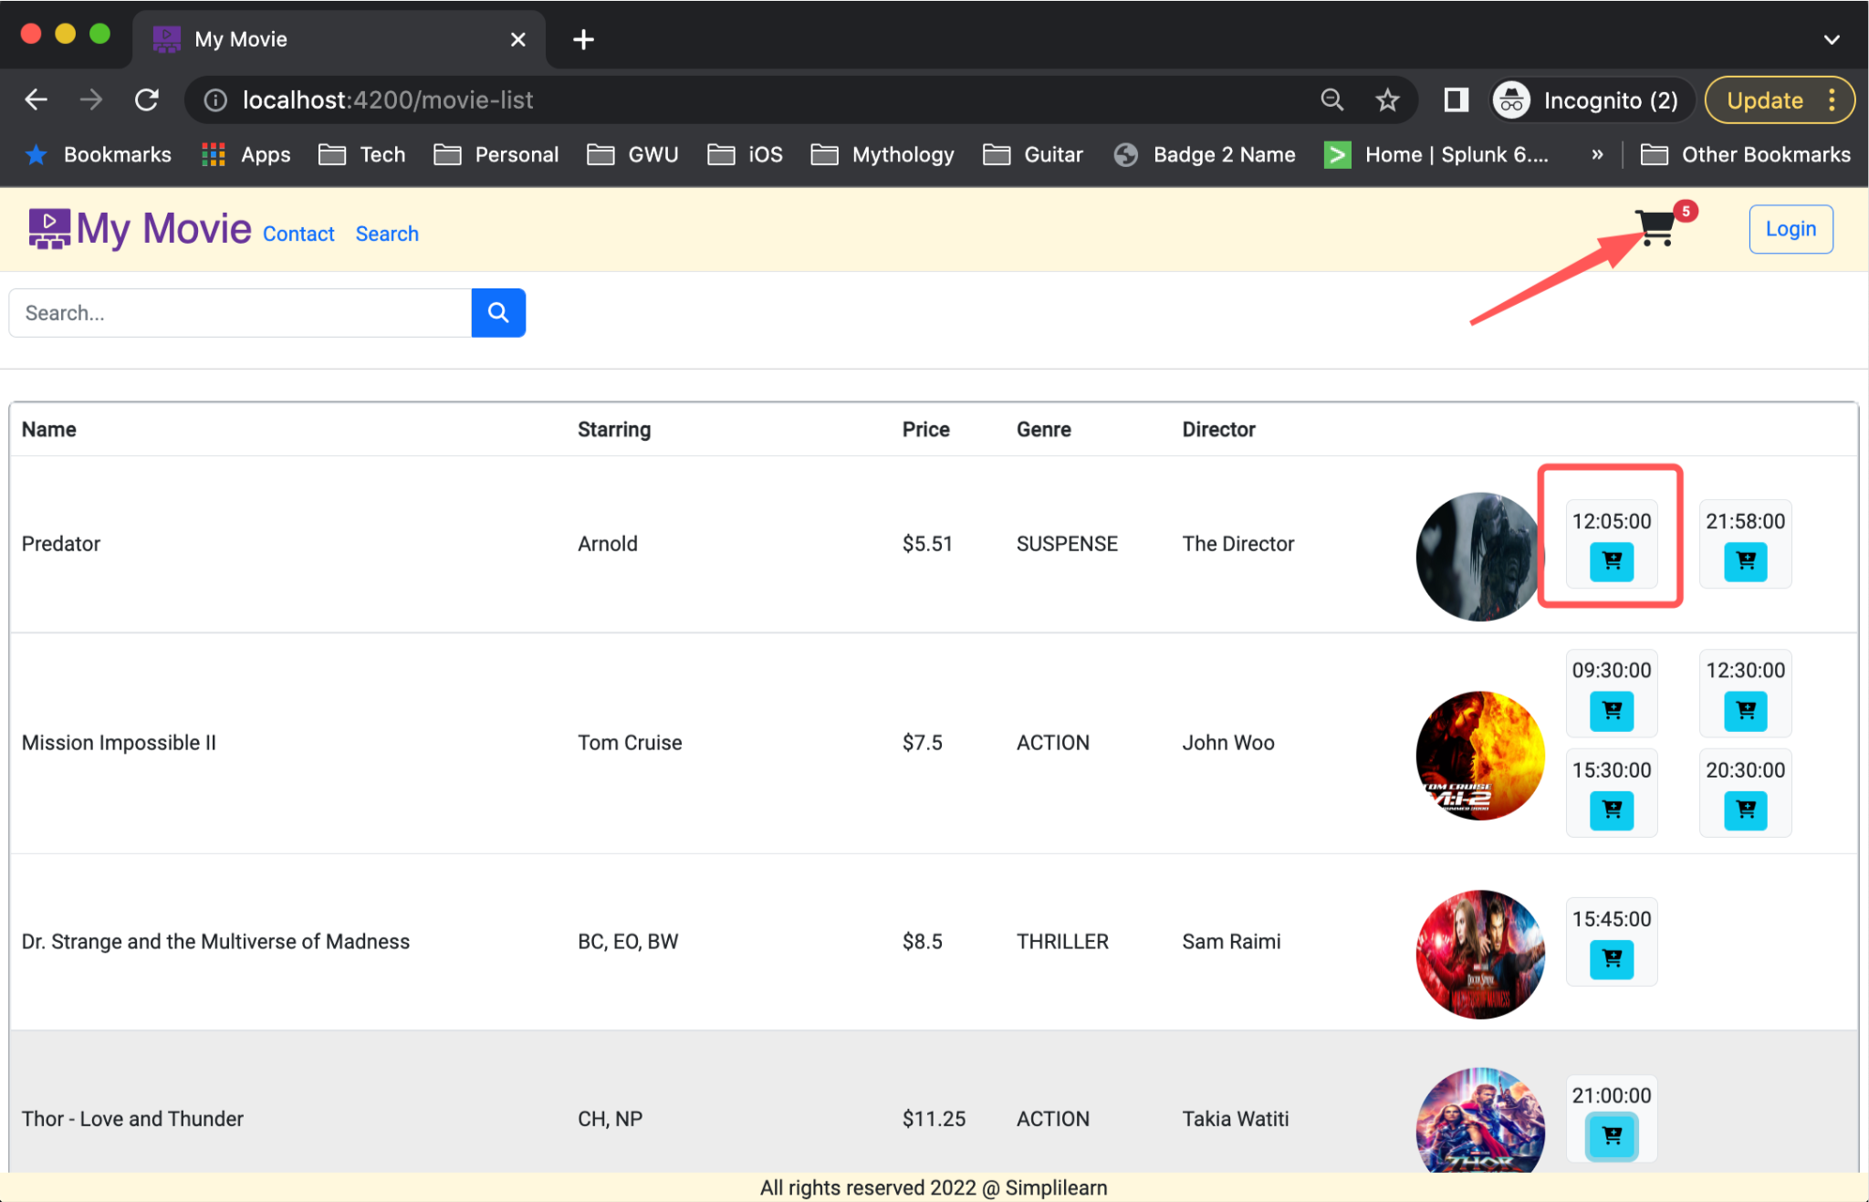

You can log in later if you decide to buy the tickets

* 1. Search by anything using the universal search bar. You can search by movie name, director, genre, etc.

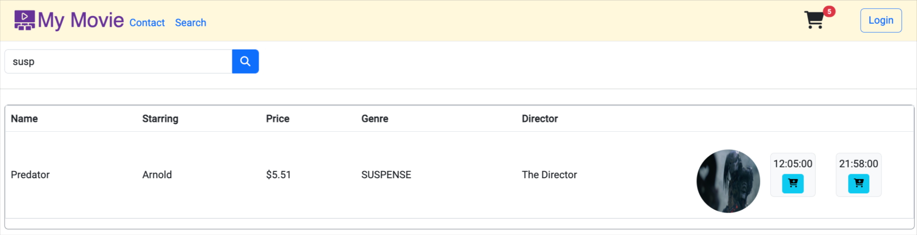

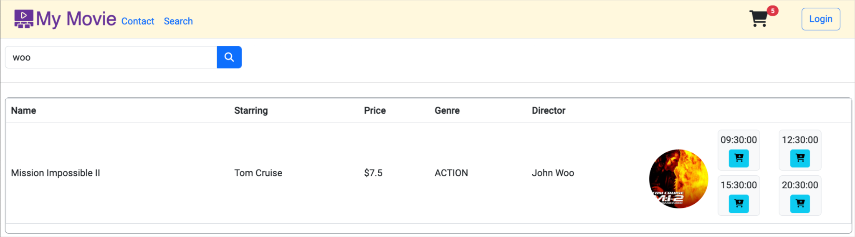

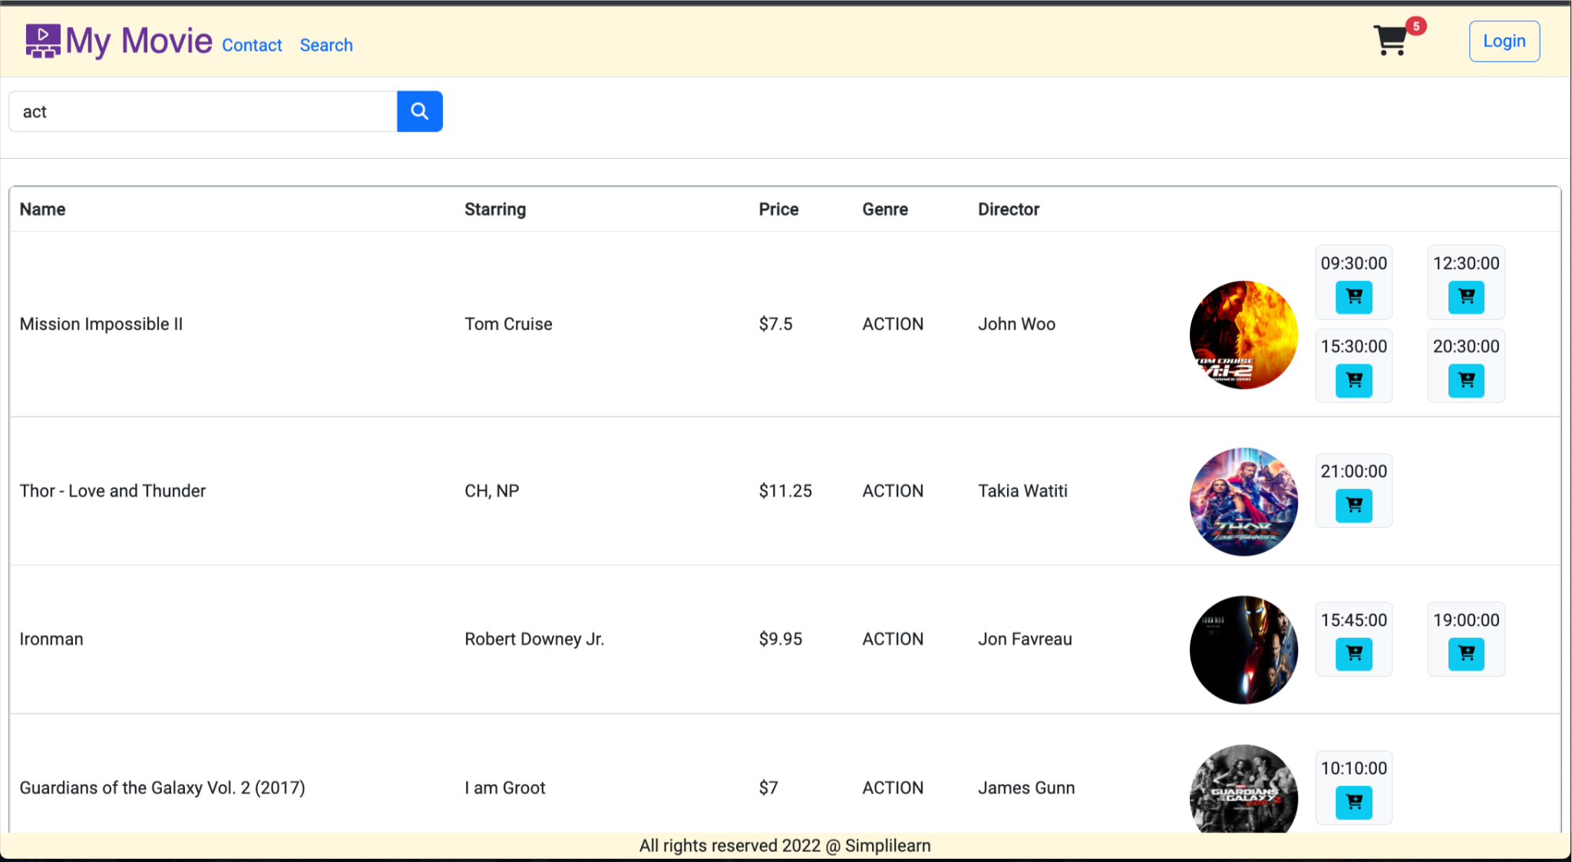

* 1. User can click on the cart to move to the Purchase screen; 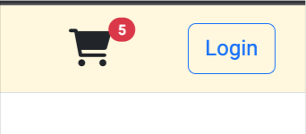

1. Purchase
   1. The user can review his choices

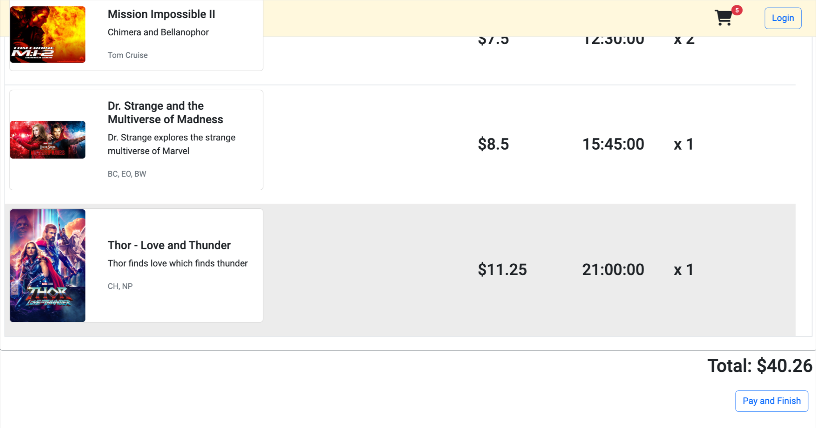

* 1. The user can click on the finish and pay button to complete transaction; the user would however be directed to the Login Screen if not already logged in



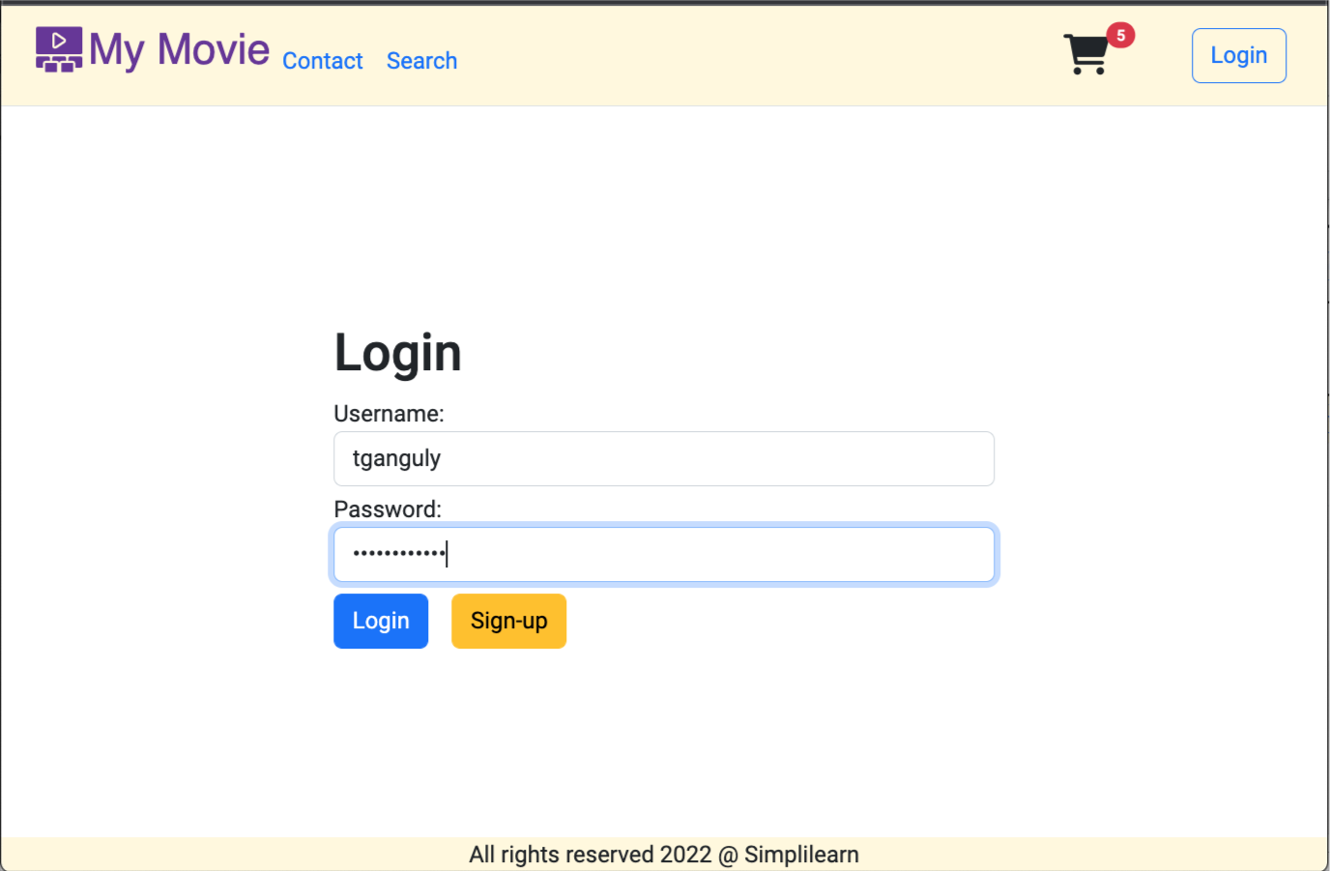

* 1. The previously chosen movies will still be available after the user logs in

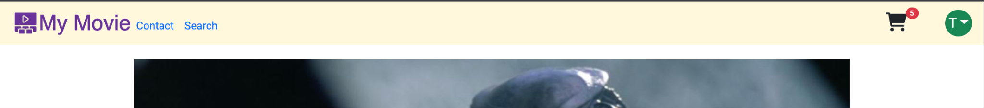

* 1. The user can now finish and pay

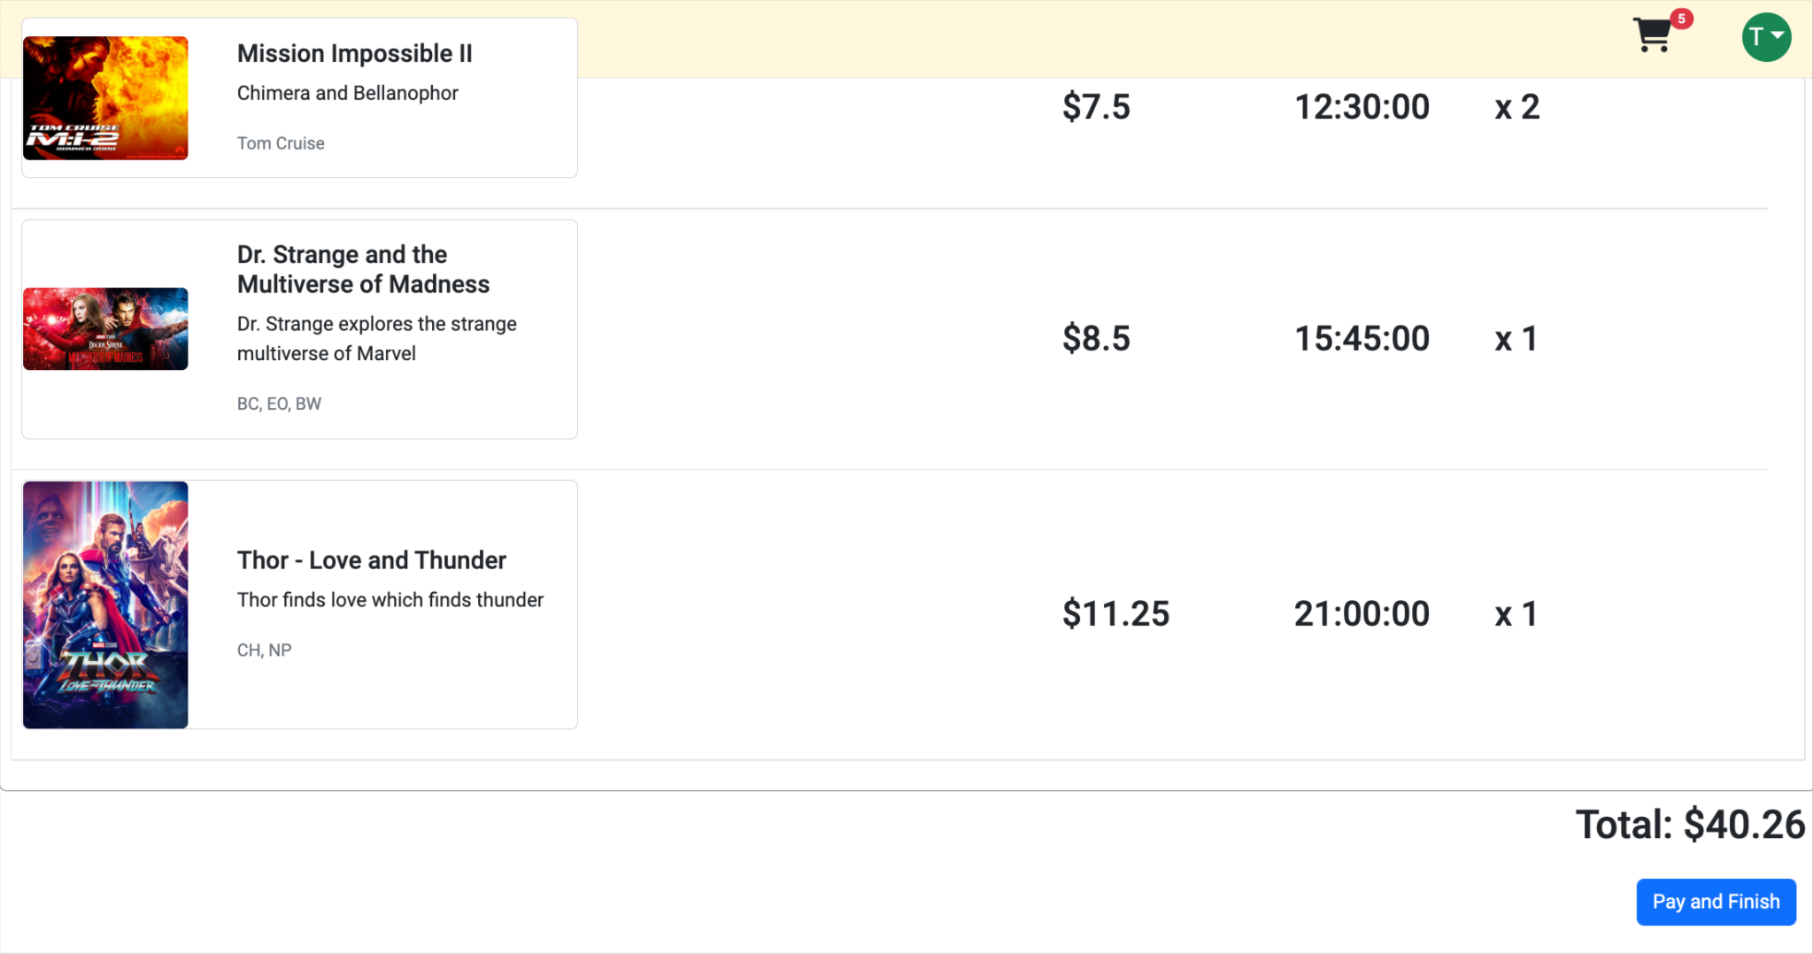

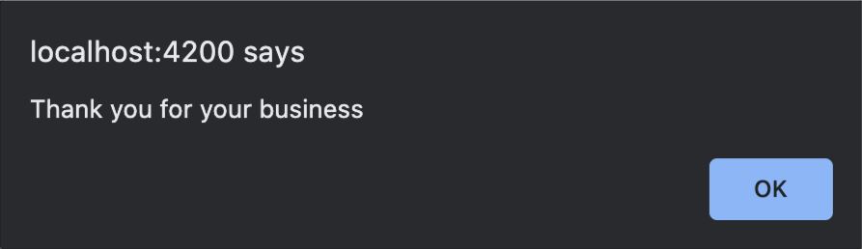

* 1. Cart is cleared

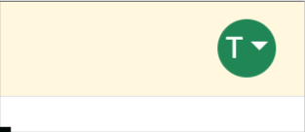

* 1. Data is save in the database

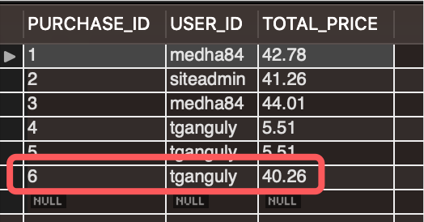

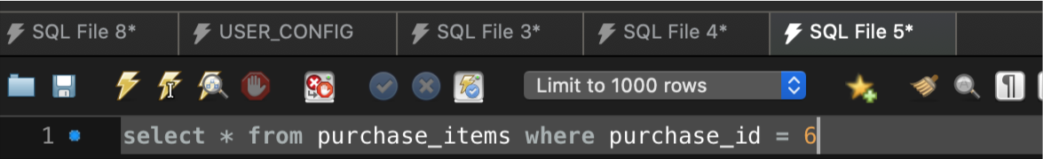

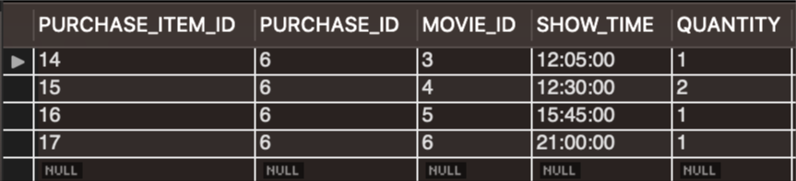

1. Add/Edit
   1. The Admin user would be able to add/edit movies

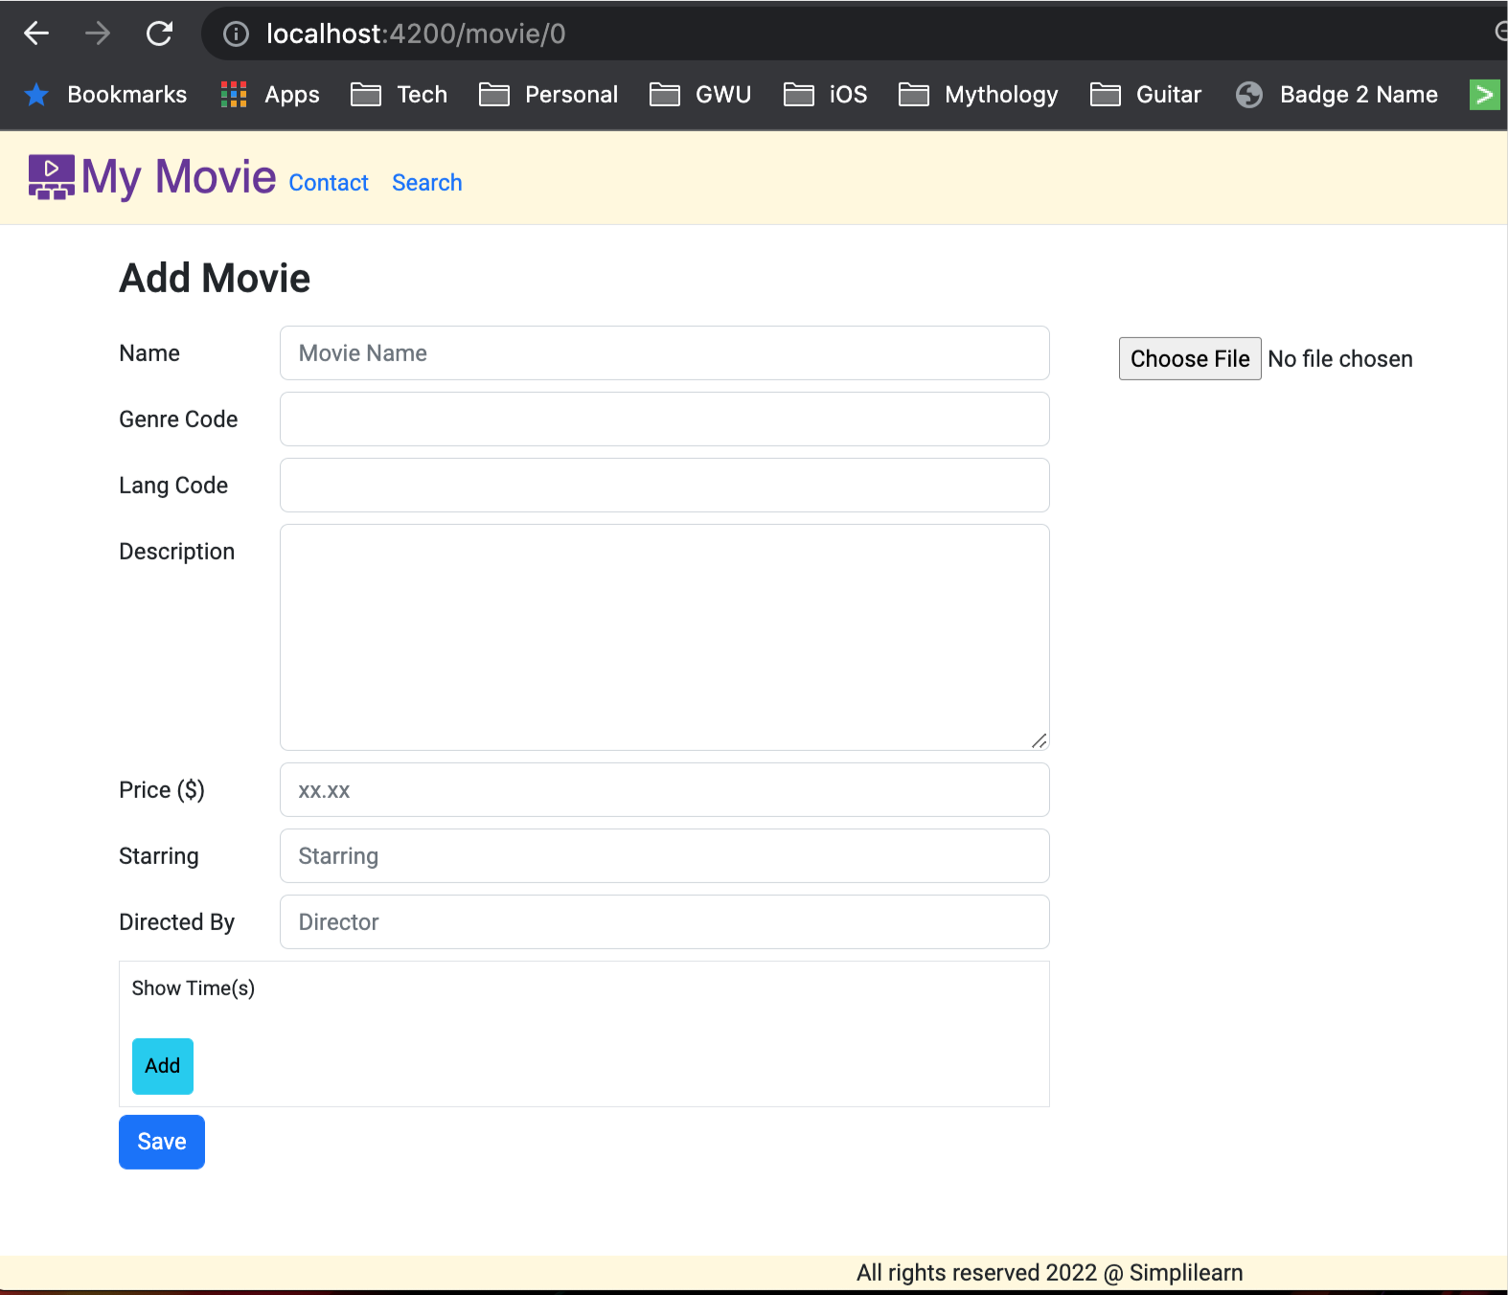

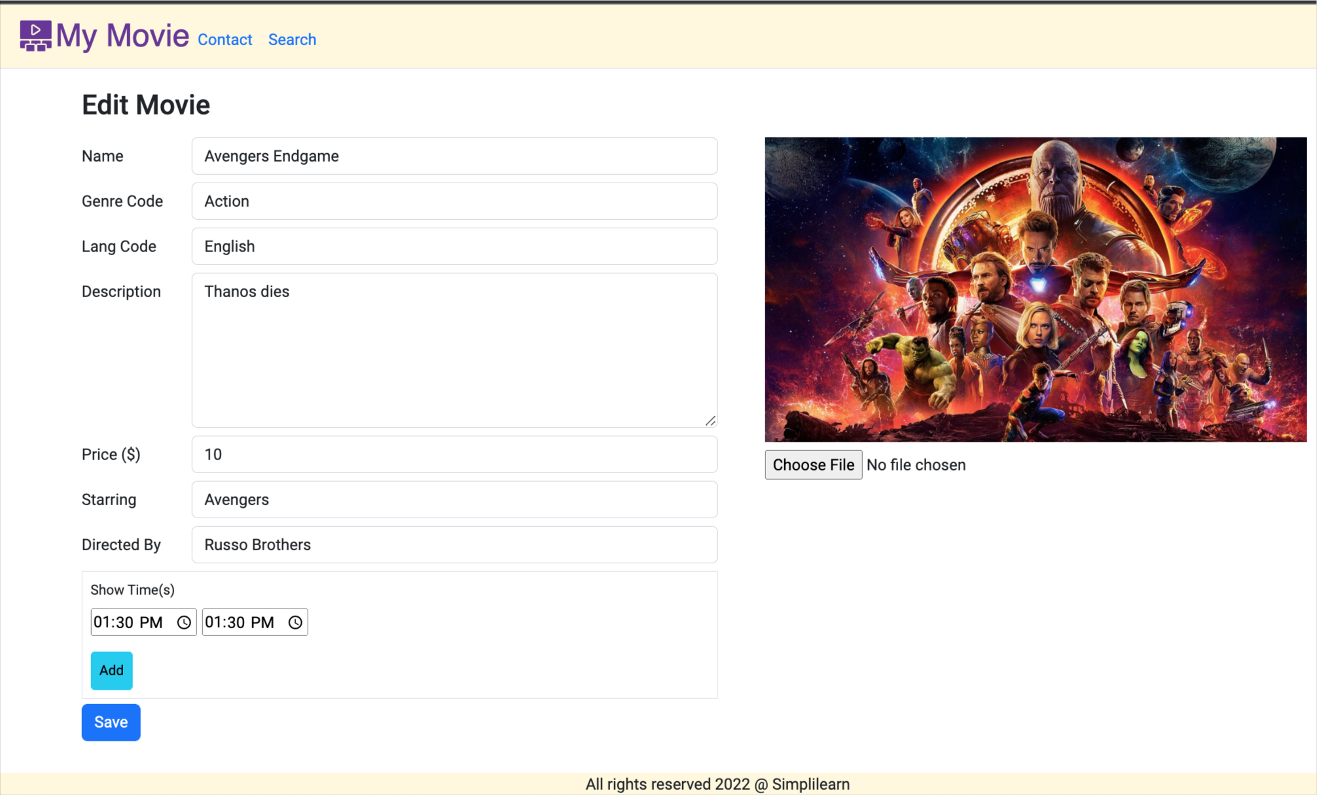

1. Register User
   1. New user will be able to register

